Contents

Welcome to Jira 1

Jira Resources 1

JQL 1

Using this Guide 2

Unit 1: Navigating in Jira 2

Lesson 1: Finding Your Projects 2

Hands on Exercise: Finding your Projects 2

Conclusions: 3

Lesson 2: Finding Issues 3

Hands on Exercise: Go to DIRA-5 by using the direct URL. 3

Hands on Exercise: Find all issues in DIRA project that are not closed and are in the “In Progress” status. 3

Lesson 3: Finding and Switching Between Boards 4

Lesson 4: The backlog vs Current Sprint/Kanban views 4

Figure 2 Hamburger Nav 2

Figure 1 Jira Main Nav 2

Figure 3. Recent Projects in Project Board 3

Figure 4 Kanban board contextual search 3

Figure 5 Project Screen Agile Boards Menu 4

Figure 6 Project Contextual Navigation 4

# Welcome to Jira

If you have problems with Jira, please don't reach out to the help desk, contact Emily Hall directly via SameTime, or email if she is not online. If she can't solve your problem, she will connect you with Jira Support (<https://support.atlassian.com/contact/#/>), they are generally very responsive and helpful.

## Jira Resources

Jira has a robust online user community (<https://community.atlassian.com/>) and copious documentation (<https://confluence.atlassian.com/alldoc/atlassian-documentation-32243719.html>) freely available online.

## JQL

Jira uses JQL (Java Query Language) for its advanced search, Jira provides an online guide to its use: <https://support.atlassian.com/contact/#/>.

## Using this Guide

This guide is intended to be a self-directed learning guide for familiarizing yourself with the Jira Could interface. Each lesson contains a hands-on exercise during which you will log into Jira and complete a task or tasks.

If you have not yet received a Jira login, please contact Emily Hall ([emliy.hall@kofc.org](mailto:emliy.hall@kofc.org)) to request a Jira account.

Login Directions:

1. The Jira instance address: <https://kofcsupreme.atlassian.net/>
2. Your username will be your KofC email address.

# Unit 1: Navigating in Jira

## Lesson 1: Finding Your Projects

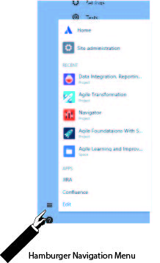There are two ways to find Jira projects, both are found in the left navigation menu.

Labeled as A in Figure 2, the Projects menu item takes you to the projects page. Labeled as B in Figure 2, the hamburger navigation menu opens a pop-up menu (shown in Figure 1) in which recent projects are listed.

### Hands on Exercise: Finding your Projects

Step 1: From the Jira home page (Dashboards) click on the Projects menu item in the left navigation (A in Figure 2).

Step 2: Select any Project you see listed there.

Figure 2 Hamburger Nav

Figure 1 Jira Main Nav

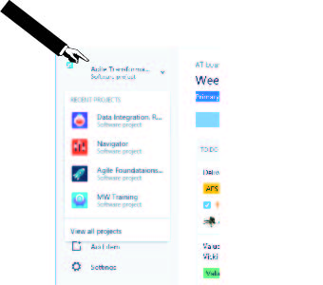Step 3: Click on the hamburger menu (B in Figure 2) and click on any project you see there.

Step 4: Click on the name of the project you are in at the top of the left navigation to open another listing of the recent projects (see figure 3).

### Conclusions:

Only projects you have access to will be visible on the projects screen. Contextual Project navigation is available on every screen in the Jira app.

## Lesson 2: Finding Issues

Figure 3. Recent Projects in Project Board

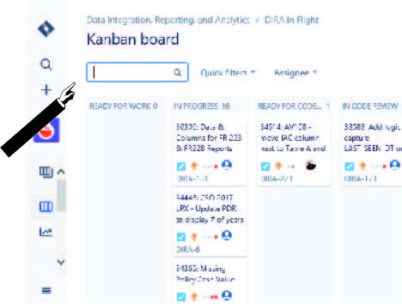Jira provides interfaces for both contextual and comprehensive searches. Within the scope of project Kanban and Jira boards. The search boxes on boards, issues, and project screens will search within the displayed information on the page.

The issue navigator is accessed through the left navigation’s Issues menu item (C in Figure 2). The issue navigator allows users to search all issue in Jira using JQL (Java Query Language) to search all metadata associate with Jira issues including date, text, and Boolean fields as well as the data stored in the issue’s change history.

Searches executed in the issue navigator can be saved as filters and used power boards and dashboard widgets.

### Hands on Exercise: Go to DIRA-5 by using the direct URL.

Figure Kanban board contextual search

Issue URL template: [*https://[YourJiraServerURL]/browse/[IssueKey]*](https://[YourJiraServerURL]/browse/%5bIssueKey)

Step 1: Construct your URL using the template above.

Step 2: Cut and paste into a browser.

You should see issue DIRA-5 display not within the context of a Jira agile board.

### Hands on Exercise: Find all issues in DIRA project that are not closed and are in the “In Progress” status.

Step 1: In the left navigation, click the Issues navigation menu item (C in Figure 2).

Step 2: Click on All Issues

Step 3: Click on Advanced Search in the upper right area of the screen.

Step 4: Construct your JQL query and click execute the search

Step 5:

## Lesson 3: Finding and Switching Between Boards

#### Agile Boards on the Projects Screen

Within the Jira projects screen, in the recent projects bar, a dropdown menu of the agile boards available for those projects.

Because the issues displayed on an agile board can be pulled from many project, the same board could be displayed under multiple projects.

#### Agile Projects Contextual Issues

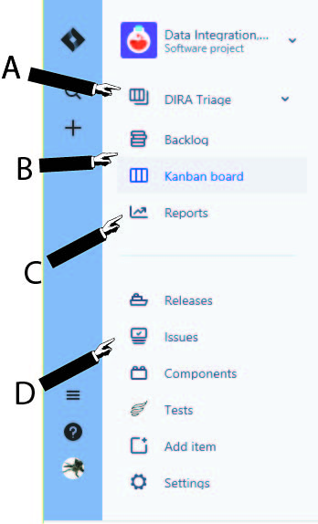Jira provides a contextual navigation menu within the each jira project. This navigation menu allows users to move between boards (A in Figure 5), views (B in Figure 5), reports (C in Figure 5), and other project specific screens and access to the issue navigator (D in Figure 5).

Figure Project Screen Agile Boards Menu

## Hands on Exercise: Switch Boards

Step 1: Select the current board (A in Figure 5) to display the available boards.

Step 2: Select one of the other available boards.

Observe that the board name and perhaps the menu items in the project contextual navigation change to reflect the name and view options of the selected boards. Scrum boards and some Kanban boards will display the Backlog menu item.

Figure Project Contextual Navigation

## Lesson 4: The backlog vs Current Sprint/Kanban views